Heap and Heapsort Analysis
Time complexity for Heapify

Let h be the height of the tree. There exists exactly one essentially complete binary tree with n nodes. Its height is equal to .

According to this property,
The number of nodes in a tree of height h, n= 2^{h+1}-1.
Each key on level i of the tree will travel to the leaf level h in the worst case of the heap construction algorithm. Since moving to the next level down requires two comparisons—one to find the larger child and the other to determine whether the exchange is required—the total number of key comparisons involving a key on level i will be 2(h − i). Therefore, the total number of key comparisons in the worst case will be
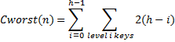
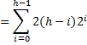
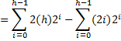
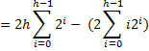

Hint:
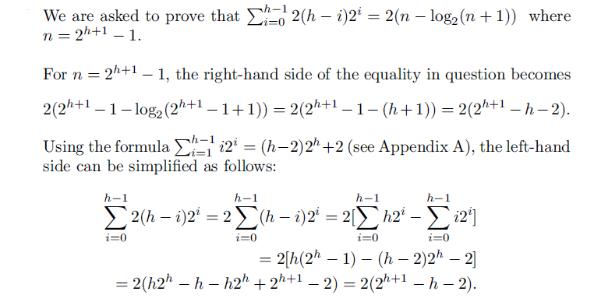
Maximum Key Deletion from a heap
The efficiency of deletion is determined by the number of key comparisons needed to “heapify” the tree after the swap has been made and the size of the tree is decreased by 1. Since this cannot require more key comparisons than twice the heap’s height, the time efficiency of deletion is in O(log n) as well.

Time complexity for Heapsort

C(n)= Time complexity for Heap construction + Time complexity for maximum deletions

C₁(n)= Time complexity for Heap construction (or Heapify) = Ɵ(n)

The number of key comparisons, C(n), needed for eliminating the root keys from the heaps of diminishing sizes from n to 2, we get the following inequality:
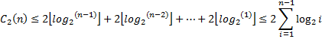
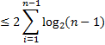
Time complexity for heapsort, C(n)=C₁(n) + C₂(n)

